**Circuit**

Power Supply

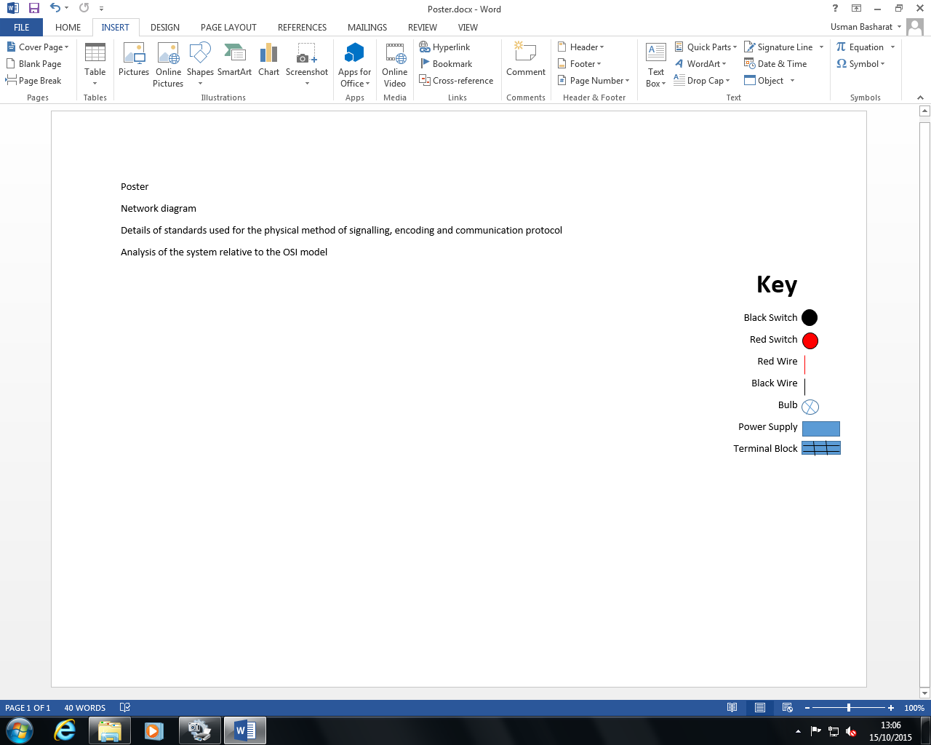**Key**

Black Switch

Red Switch

Red Wire

Network Diagram

Black Wire

Bulb

Power Supply

Terminal Block

Black Crocodile

Red Crocodile

**Protocol**

We are going to use Morse code within our system. The way it is going to work is that each person is assigned to a number, as shown below. Using switches, this would enable communication among each person. Turning the light on once would indicate that a message is incoming for the first person. However, the message can lead to an error very easily. If a user makes a mistake by pressing the switch once when the user is meant to press the switch twice. This would confuse both Person 1 and Person 2. To try to avoid that mistake, time will be taken for each message to be delivered. Referring to the picture, this would be an example of how each one would work. If ‘HI’ is supposed to be translated, it would be to press H(4) and I(2). The numbers between the brackets indicate how many times the switch needs to be pressed.

First Person = 1

Second Person = 2

Third Person = 3

Fourth Person 4

Dot – once

Block - twice

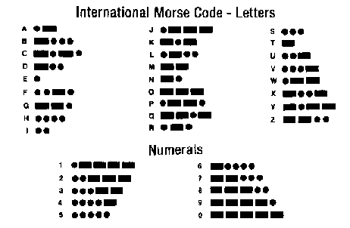

*Image Source:* [*http://www.geocities.ws/phoda2000/morse.gif*](http://www.geocities.ws/phoda2000/morse.gif)

**Standard**

Using the protocols, we use Morse code to communicate between people in different rooms. It allows everyone to communicate to everyone else whenever someone clicks the button/switch all four lights light up. However, by pressing all four switches would be confusing. However, the first thing we are going to do is changing how we are going to communicate. Whomever we are going to send the message to, we can press the switch once and then direct the message. This would direct the message to the person who is in one. In addition, then the message can be directed. However, the message is going to be sent to the everyone. Once the person receives the message, he will respond to the person that send it, send his message and that would be the end of it. We can error check the system by waiting 10 seconds once the error occurs. For example, if I press the switch twice instead of once, I would wait 10 seconds for it to happen. The limitation of the system is that only once person can talk at a time and they all receive the message. Similar to a walkie-talkie.

**OSI Model**

**Physical layer**

Physical layer is the last part where it uses the cable to get to the destination. This means how the data links with each other. In this content, the physical layer is each cable that is connected with each other.

**Data link layer**

Data link layer is when the light bulbs and switches are connected with each other to enable communication. In other terms, data link layer is can be used when sending information to someone else. This part would need the modem.

**Network layer**

The network layer is the whole network of the circuit being complete. This means all the cables, switches, light bulbs and power supply are fully connected with each other. This would enable the network to be accessed.

**Transport layer**

The communication travels through the wires to send a message to another person. In other words, transport layer is when it is like the taxi. You need to get to another place. It is the same context in terms of message.

**Session layer**

This is the part where it ‘takes off’. Therefore, once you press the switch three times, which would identify the letter in Morse code.

**Presentation layer**

The presentation layer is so that the other person can understand what is being said. Therefore, once I have pressed the switch three times, it would identify the letter it takes.

**Application layer**

The application layer is so that the message has been converted. Therefore, once all of the others have been complete, the other person can send a message to another person.